Exp7
Working with jQuery
Budget Calculator
Code:
<!DOCTYPE html>
<html lang="en">
<head>
<meta charset="UTF-8">
<meta name="viewport" content="width=device-width, initial-scale=1.0">
<title>Budget Calculator App</title>

<script src="https://ajax.googleapis.com/ajax/libs/jquery/3.6.0/jquery.min.js"></script>

<style>
body {
font-family: Arial, sans-serif;
text-align: center;
background: white;
}

.container {
max-width: 650px;
margin: 30px auto;
padding: 20px;
}

h3 {
background: black;
color: white;
padding: 10px;
}

input {
width: 65px;
padding: 5px;
margin: 5px;
}

.percentages {
margin: 20px 0;
}

button {
background: #172c91;
color: white;
border: none;
padding: 10px 18px;
cursor: pointer;
}

.results {
display: flex;
justify-content: center;
flex-wrap: wrap;
gap: 10px;
margin-top: 25px;
}

.box {
color: white;
padding: 12px;
min-width: 75px;
font-size: 13px;
}

.blue { background: blue; }
.green { background: green; }
.purple { background: purple; }
.pink { background: deeppink; }
</style>
</head>

<body>
<div class="container">

<h3>Budget Calculator App</h3>

<p>Enter Amount that you want to Manage</p>

<input type="number" id="amount" value="15000"
min="0">

<p>How would you like to divide your money?</p>

<div class="percentages">
Room Rent (%) <input type="number" id="rent" value="50">
Accessories (%) <input type="number" id="accessories" value="20">
Emergency (%) <input type="number" id="emergency" value="20">
Saving (%) <input type="number" id="saving" value="10">
</div>

<button id="evaluate">Evaluate My Money</button>

<div class="results">
<div class="box blue">
Room Rent
<h4 id="rentResult">Rs.7500</h4>
</div>

<div class="box green">
Accessories
<h4 id="accessoriesResult">Rs.3000</h4>
</div>

<div class="box purple">
Emergency
<h4 id="emergencyResult">Rs.3000</h4>
</div>

<div class="box pink">
Saving
<h4 id="savingResult">Rs.1500</h4>
</div>
</div>

</div>

<script>
$(document).ready(function() {

$("#evaluate").click(function() {

let amount = Number($("#amount").val());

let rent = Number($("#rent").val());
let accessories = Number($("#accessories").val());
let emergency = Number($("#emergency").val());
let saving = Number($("#saving").val());

let total = rent + accessories + emergency + saving;

if ($("#amount").val() === "" ||
amount <= 0 ||
[rent, accessories, emergency, saving].some(
p => p < 0 || p > 100
) ||
total !== 100) {

alert("Please enter a valid amount and percentages totaling 100%.");
return;
}

$("#rentResult").text("Rs." + amount * rent / 100);
$("#accessoriesResult").text("Rs." + amount * accessories / 100);
$("#emergencyResult").text("Rs." + amount * emergency / 100);
$("#savingResult").text("Rs." + amount * saving / 100);

});

});
</script>

</body>
</html>
Output:
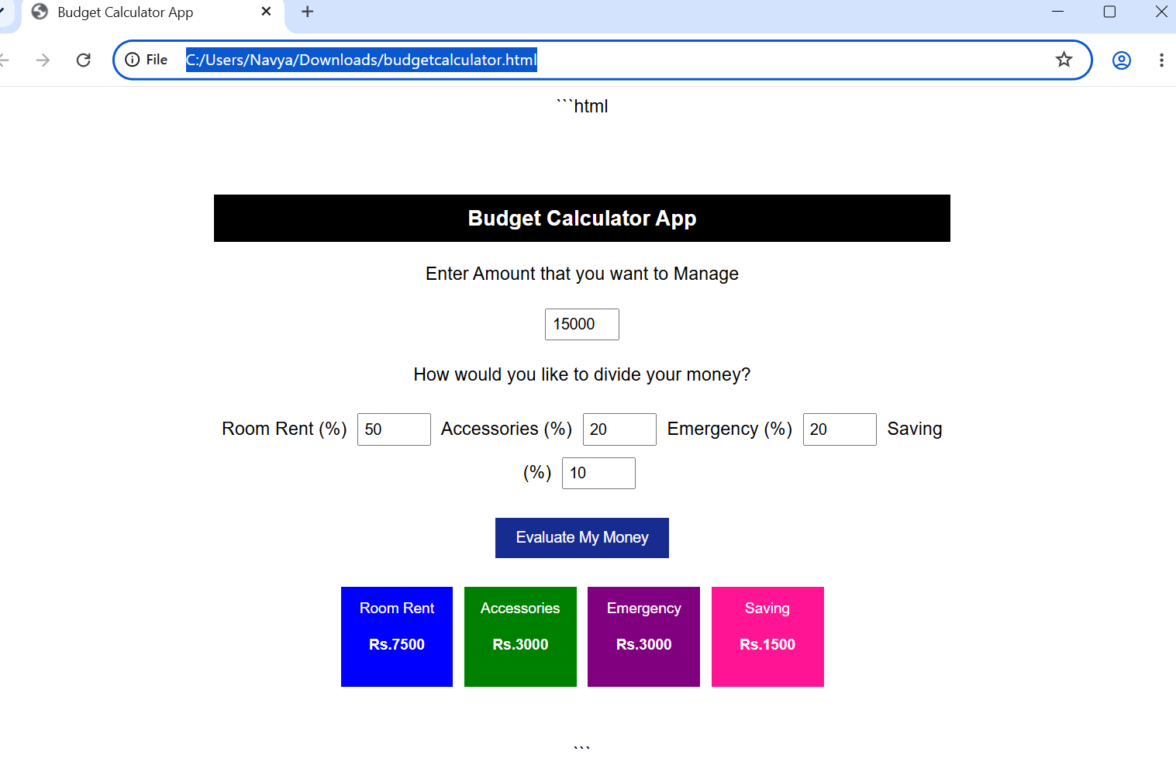
Cake Order Calculator
Code:
<!DOCTYPE html>
<html lang="en">
<head>
<meta charset="UTF-8">
<meta name="viewport" content="width=device-width, initial-scale=1.0">
<title>Cake Shop</title>

<script src="https://ajax.googleapis.com/ajax/libs/jquery/3.6.0/jquery.min.js"></script>

<style>
body {
font-family: Arial, sans-serif;
text-align: center;
background: white;
}

.shop {
max-width: 650px;
margin: 20px auto;
padding: 15px;
}

h3 {
background: #b50000;
color: white;
padding: 10px;
}

.cakes {
display: grid;
grid-template-columns: repeat(4, 1fr);
gap: 8px;
}

.cake {
padding: 10px 3px;
background: #f5f5f5;
font-size: 12px;
}

.cake .emoji {
font-size: 45px;
}

h2 {
color: #172c91;
font-size: 22px;
}

.orders {
max-width: 400px;
margin: auto;
text-align: left;
}

label {
display: block;
color: #172c91;
font-size: 13px;
margin-top: 10px;
}

input {
width: 100%;
padding: 7px;
box-sizing: border-box;
}

button {
display: block;
margin: 15px auto;
padding: 10px 30px;
background: #0874df;
color: white;
border: none;
cursor: pointer;
}

hr {
border: 1px solid #7777cc;
}

.total {
background: green;
color: white;
padding: 8px;
display: inline-block;
min-width: 150px;
}

#price {
color: #b50000;
display: inline-block;
margin-left: 10px;
}

@media(max-width: 450px) {
.cakes {
grid-template-columns: repeat(2, 1fr);
}
}
</style>
</head>

<body>
<div class="shop">

<h3>CAKE SHOP</h3>

<div class="cakes">
<div class="cake">
<div class="emoji">🎂</div>
Color Cake - Rs.300
</div>

<div class="cake">
<div class="emoji">🍰</div>
Brown Cake - Rs.200
</div>

<div class="cake">
<div class="emoji">🎂</div>
Milky Cake - Rs.250
</div>

<div class="cake">
<div class="emoji">🍫</div>
Black Forest Cake - Rs.650
</div>
</div>

<h2>Order Cake</h2>

<div class="orders">

<label>Color Cake (Quantity)</label>
<input type="number" id="color" value="2" min="0">

<label>Brown Cake (Quantity)</label>
<input type="number" id="brown" value="1" min="0">

<label>Milky Cake (Quantity)</label>
<input type="number" id="milky" value="2" min="0">

<label>Black Forest Cake (Quantity)</label>
<input type="number" id="black" value="1" min="0">

<button id="order">Place Order</button>

<hr>

<h3 style="background:white;color:#172c91;">
Purchase Order Bill!!
</h3>

<div class="total">Total Price</div>
<h2 id="price">Rs.1650</h2>

</div>
</div>

<script>
$(document).ready(function() {

$("#order").click(function() {

let color = Number($("#color").val());
let brown = Number($("#brown").val());
let milky = Number($("#milky").val());
let black = Number($("#black").val());

let quantities = [color, brown, milky, black];

if (quantities.some(q => !Number.isInteger(q) || q < 0)) {
alert("Please enter valid non-negative quantities.");
return;
}

let total =
(color * 300) +
(brown * 200) +
(milky * 250) +
(black * 650);

$("#price").text("Rs." + total);

});

});
</script>

</body>
</html>
Output:
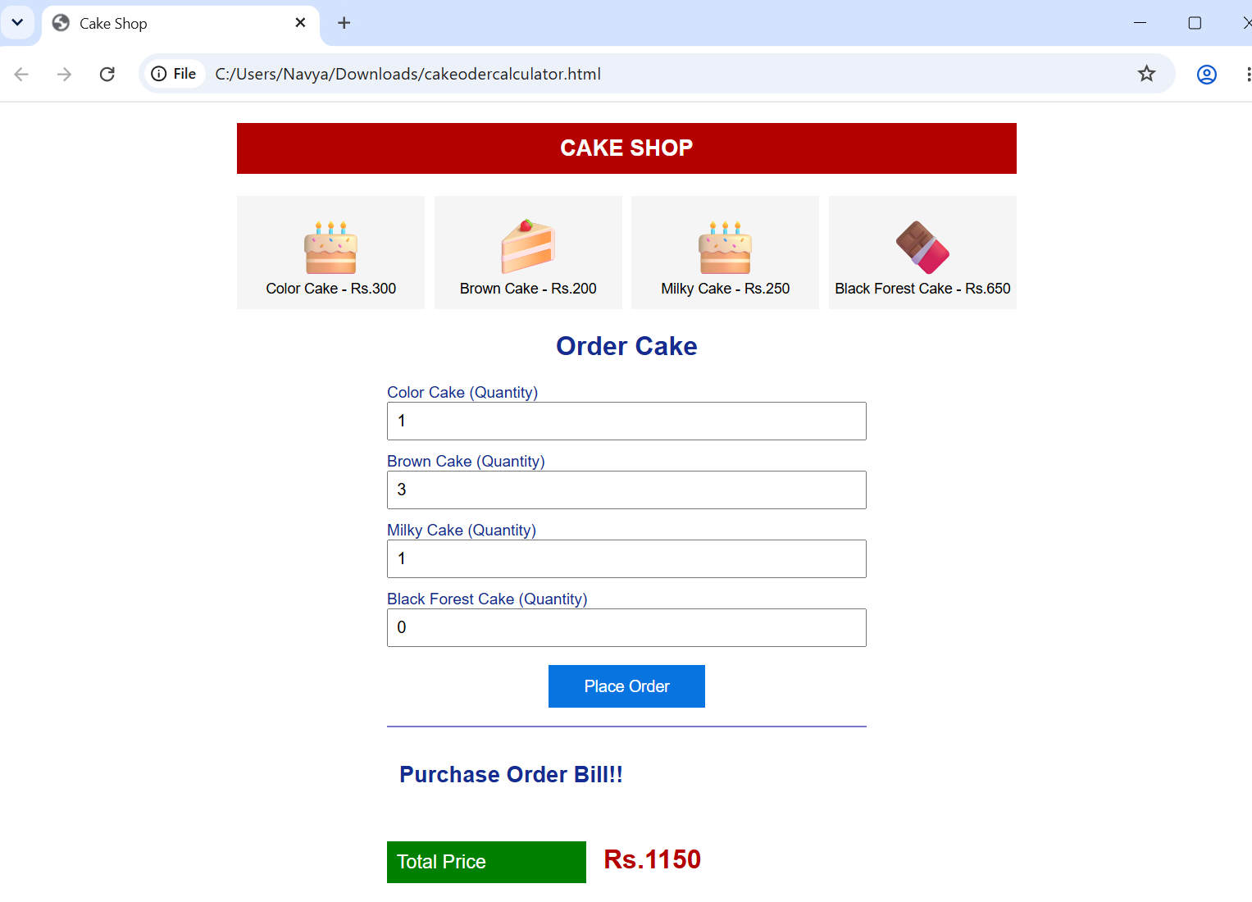Car Body Workshop
Code:
<!DOCTYPE html>
<html lang="en">
<head>
<meta charset="UTF-8">
<meta name="viewport" content="width=device-width, initial-scale=1.0">
<title>Car Workshop</title>

<script src="https://ajax.googleapis.com/ajax/libs/jquery/3.6.0/jquery.min.js"></script>

<style>
body {
font-family: Arial, sans-serif;
text-align: center;
background: white;
}

.workshop {
max-width: 650px;
margin: 30px auto;
padding: 20px;
}

h3 {
color: #3984cc;
}

.car-area {
height: 220px;
position: relative;
margin: 30px auto;
background: #f7f7f7;
border: 1px solid #ddd;
}

.car {
position: relative;
width: 240px;
height: 130px;
margin: 35px auto;
}

.roof {
position: absolute;
top: 5px;
left: 65px;
width: 110px;
height: 50px;
background: #36ae5b;
clip-path: polygon(25% 0, 75% 0, 100% 100%, 0 100%);
}

.body {
position: absolute;
top: 50px;
left: 15px;
width: 210px;
height: 45px;
background: #71e51c;
border-radius: 8px 12px 5px 5px;
}

.window {
position: absolute;
top: 14px;
left: 85px;
width: 70px;
height: 32px;
background: #a9e4f5;
z-index: 2;
clip-path: polygon(20% 0, 80% 0, 100% 100%, 0 100%);
}

.wheel {
position: absolute;
top: 82px;
width: 38px;
height: 38px;
background: #18224e;
border-radius: 50%;
border: 2px solid #ddd;
}

.left-wheel {
left: 40px;
}

.right-wheel {
right: 40px;
}

button {
padding: 9px 12px;
margin: 5px;
background: white;
border: 1px solid #8da9d4;
color: #386bb0;
cursor: pointer;
}

button:hover {
background: #dcecff;
}
</style>
</head>

<body>
<div class="workshop">

<h3>1. Car Workshop</h3>

<div class="car-area">

<div class="car">
<div class="roof"></div>
<div class="window"></div>
<div class="body"></div>
<div class="wheel left-wheel"></div>
<div class="wheel right-wheel"></div>
</div>

</div>

<button id="bodyColor">Change Body Color</button>
<button id="glassTint">Change Glass Tint</button>
<button id="increase">Tyre Size Increase</button>
<button id="decrease">Tyre Size Decrease</button>
<button id="reset">Reset</button>

</div>

<script>
$(document).ready(function() {

let colors = ["red", "blue", "orange", "purple", "pink", "green"];
let tints = ["#a9e4f5", "#444444", "#9bd7a5", "#f4d35e"];

let colorIndex = 0;
let tintIndex = 0;
let tyreSize = 38;

$("#bodyColor").click(function() {
colorIndex = (colorIndex + 1) % colors.length;
$(".body, .roof").css("background-color", colors[colorIndex]);
});

$("#glassTint").click(function() {
tintIndex = (tintIndex + 1) % tints.length;
$(".window").css("background-color", tints[tintIndex]);
});

$("#increase").click(function() {
if (tyreSize < 65) {
tyreSize += 5;
$(".wheel").css({
width: tyreSize + "px",
height: tyreSize + "px"
});
}
});

$("#decrease").click(function() {
if (tyreSize > 20) {
tyreSize -= 5;
$(".wheel").css({
width: tyreSize + "px",
height: tyreSize + "px"
});
}
});

$("#reset").click(function() {
colorIndex = 0;
tintIndex = 0;
tyreSize = 38;

$(".body").css("background-color", "#71e51c");
$(".roof").css("background-color", "#36ae5b");
$(".window").css("background-color", "#a9e4f5");

$(".wheel").css({
width: "38px",
height: "38px"
});
});

});
</script>

</body>
</html>
Output:


